**VERSION CONTROL**

**DOCUMENT**

**FOR**

**CUSTOMER SERVICES HELPDESK**

**(CUSTOMERS)**

|  |  |  |  |  |
| --- | --- | --- | --- | --- |
| **Version Control** | | | | |
| **Version** | **Author** | **Date** | **Changes** | **Reviewer** |
| 1.0.1 | Anjalee Shah | 05 Nov 2020 | First Draft | Atit Pandya |
| 1.0.2 | Anjalee Shah | 25 Nov 2020 | Remove few textboxes | Atit Pandya |
| 1.0.3 | Anjalee Shah | 04 Dec 2020 | Change in selection picker option | Atit Pandya |
| 1.0.4 | Shubham Wala | 09 Dec 2020 | Swap position and remove some fields | Atit Pandya |

**TABLE OF CONTENTS**

1. Version 1.0.1 4

2. Version 1.0.2 6

3. Version 1.0.3 7

4. Version 1.0.4 8

# Version 1.0.1

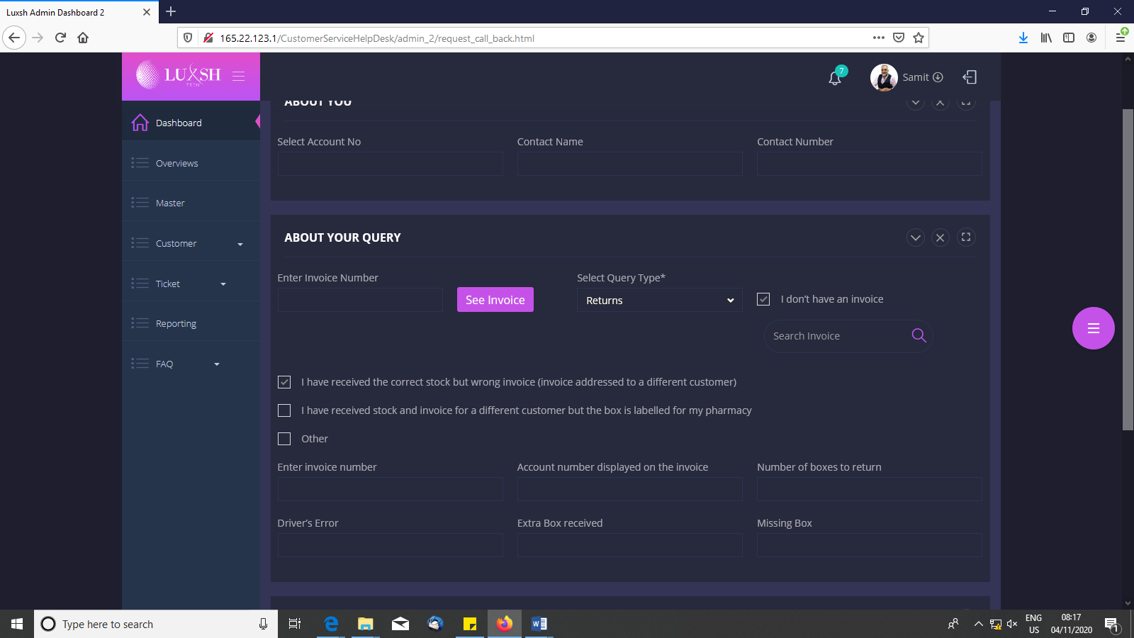

Remove below input fields which appear when “I have the correct stock but wrong invoice (invoice addressed to a different customer)” checkbox is checked:

1. Enter invoice number
2. Account number displayed on the invoice
3. Number of boxes to return
4. Driver’s Error
5. Extra Box received
6. Missing box

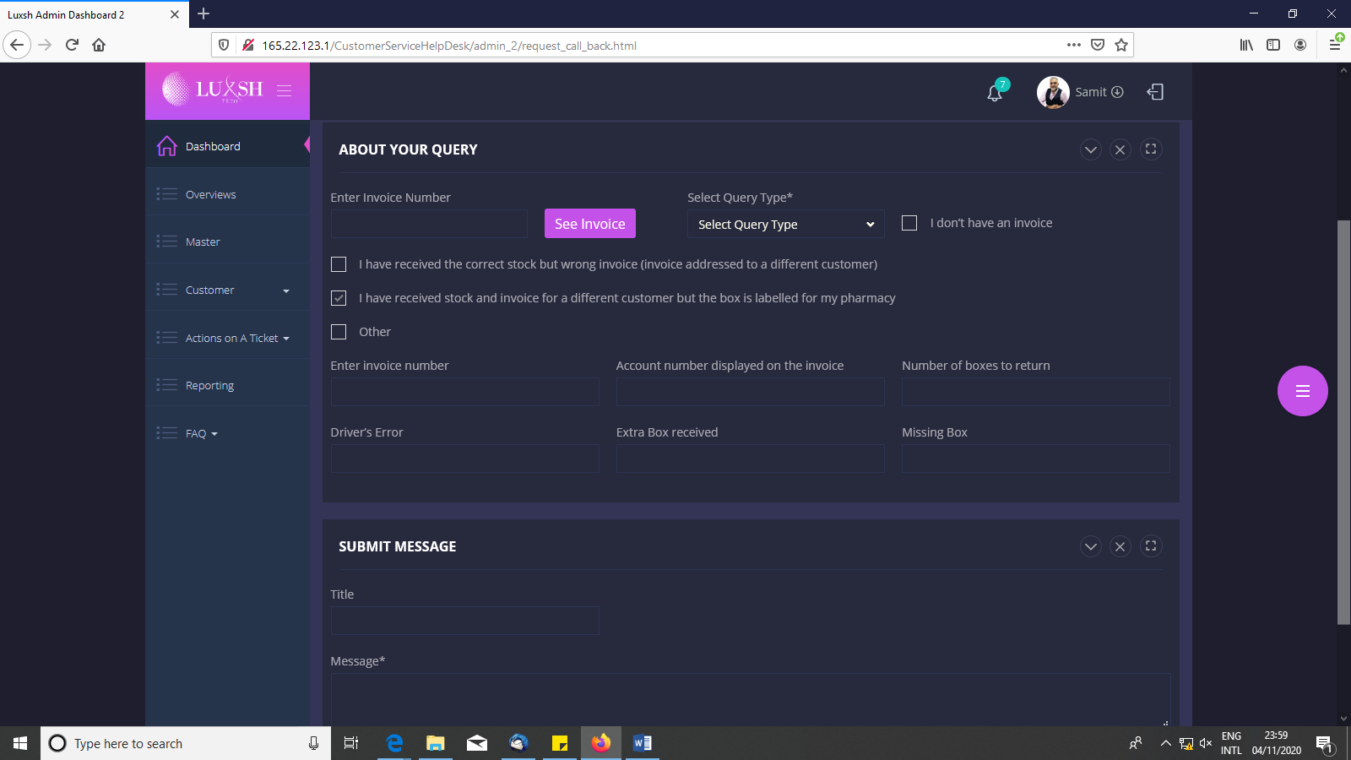

Remove below input fields which appear when “I have received stock and invoice for a different customer but the box is labelled for my pharmacy” checkbox is checked:

1. Enter invoice number
2. Account number displayed on the invoice
3. Number of boxes to return
4. Driver’s Error
5. Extra Box received
6. Missing box

# Version 1.0.2

Customer > Create a Ticket > Title* : Missings

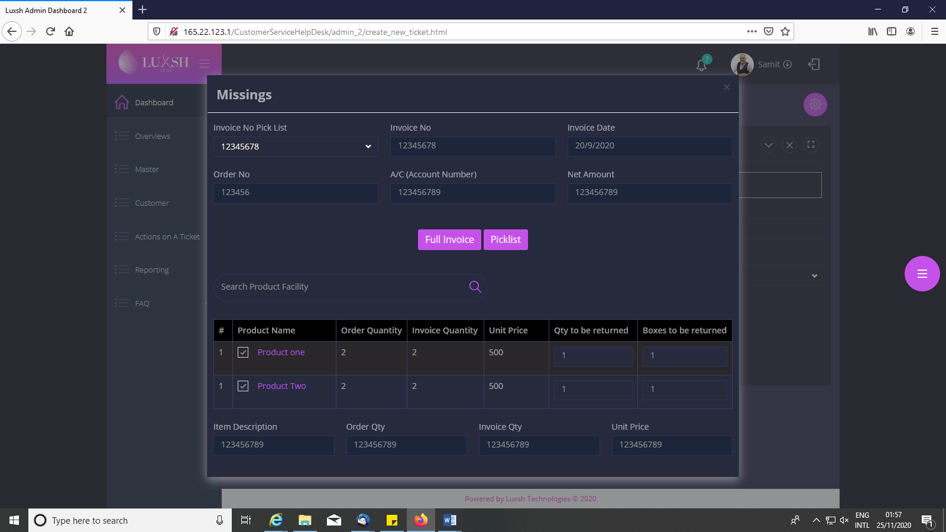

Remove below display textboxes:

1. Item Description
2. Order Qty
3. Invoice Qty
4. Unit Price

# Version 1.0.3

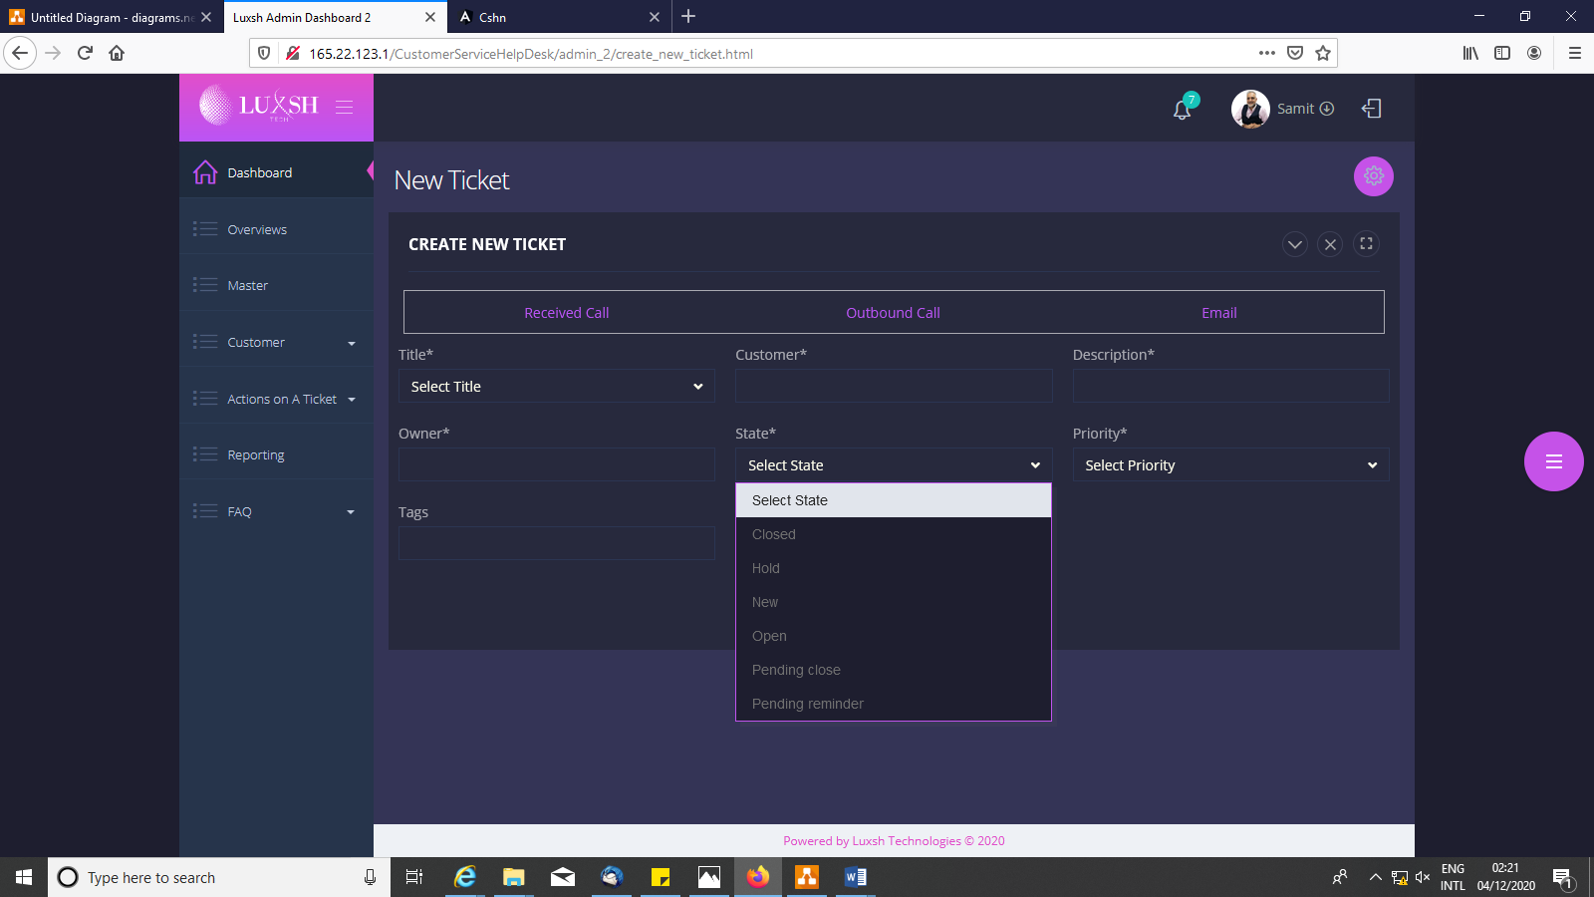

Replace these values with below new values:

1. Created
2. Closed
3. Pending
4. First Solution
5. Re-open

# Version 1.0.4



Swap position of “Title” and it’s corresponding selection picker with “Customer” and it’s corresponding textbox

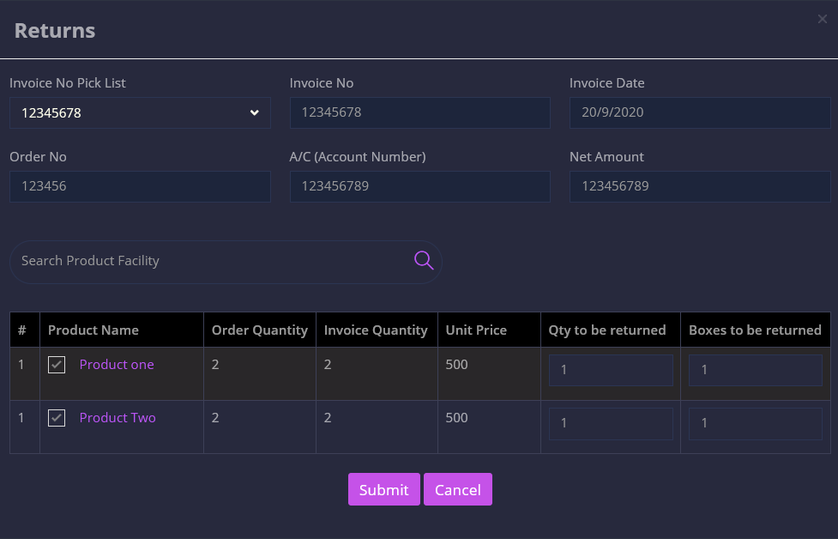

“Return Note Declaration Form” need to be displayed after submit button is clicked

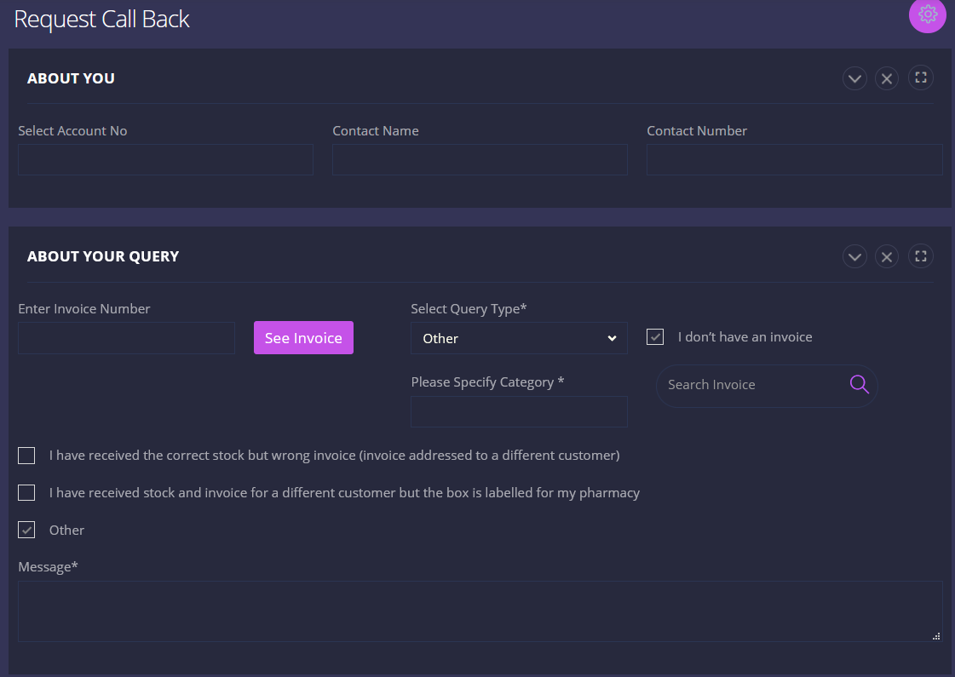

Remove “Message*” message box when “Other” checkbox is selected

Remove “Please Specify Category” and it’s corresponding textbox when “Others” option is selected from “Select Query Type*” selection picker

Remove “Search Invoice” input field which appears when “I don’t have an invoice” checkbox is selected

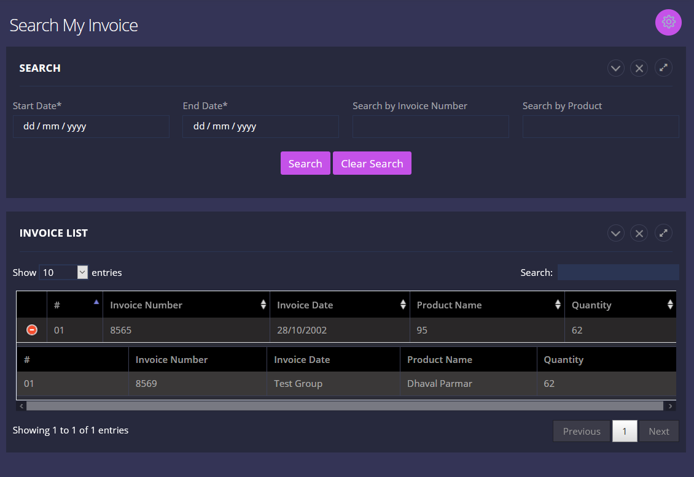

Remove “+” Collapse/Expand button and the following table which gets displayed when Collapse/Expand button is clicked from Invoice List table